Gabriel Morais Lúcio de Araújo

# Codeforces

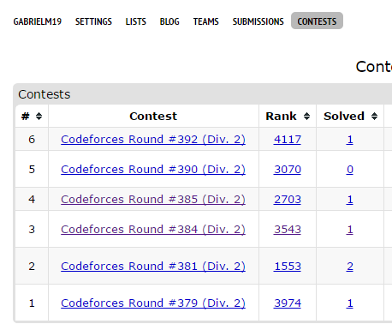

* Round #379 (Div. 2)

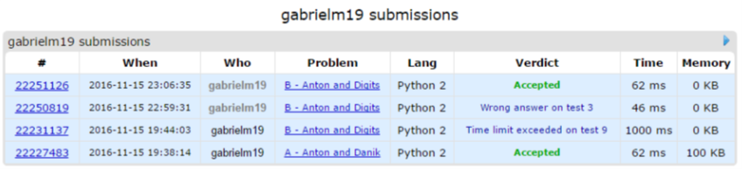

|  |  |
| --- | --- |
| Problema | Solução |
| <http://codeforces.com/contest/734/problem/A> | <http://codeforces.com/contest/734/submission/22227483> |
| <http://codeforces.com/contest/734/problem/B> | <http://codeforces.com/contest/734/submission/22251126> |

* Round #381 (Div. 2)

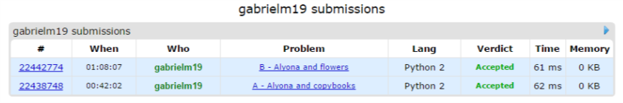

|  |  |
| --- | --- |
| Problema | Solução |
| <http://codeforces.com/contest/740/problem/A> | <http://codeforces.com/contest/740/submission/22438748> |
| <http://codeforces.com/contest/740/problem/B> | <http://codeforces.com/contest/740/submission/22442774> |

* Round #384 (Div. 2)

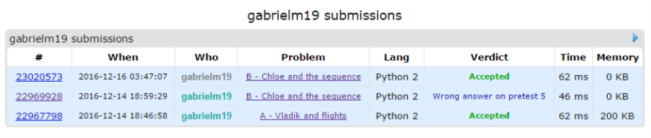

|  |  |
| --- | --- |
| Problema | Solução |
| [http://codeforces.com/contest/743/problem/A](http://codeforces.com/contest/734/problem/A) | <http://codeforces.com/contest/743/submission/22967798> |
| <http://codeforces.com/contest/743/problem/B> | <http://codeforces.com/contest/743/submission/23020573> |

* Round #385 (Div. 2)

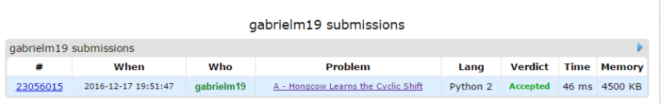

|  |  |
| --- | --- |
| Problema | Solução |
| <http://codeforces.com/contest/745/problem/A> | <http://codeforces.com/contest/745/submission/23056015> |

* Round #392 (Div. 2)

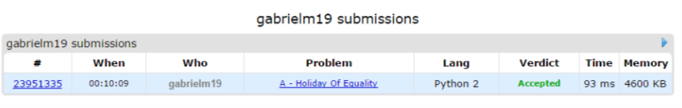

|  |  |
| --- | --- |
| Problema | Solução |
| <http://codeforces.com/contest/758/problem/A> | <http://codeforces.com/contest/758/submission/23951335> |

# Uri

* Maratona de programação - Final Brasileira 2016

# 

|  |  |
| --- | --- |
| Problema | Solução |
| A |  |

* Contest de Natal 2016

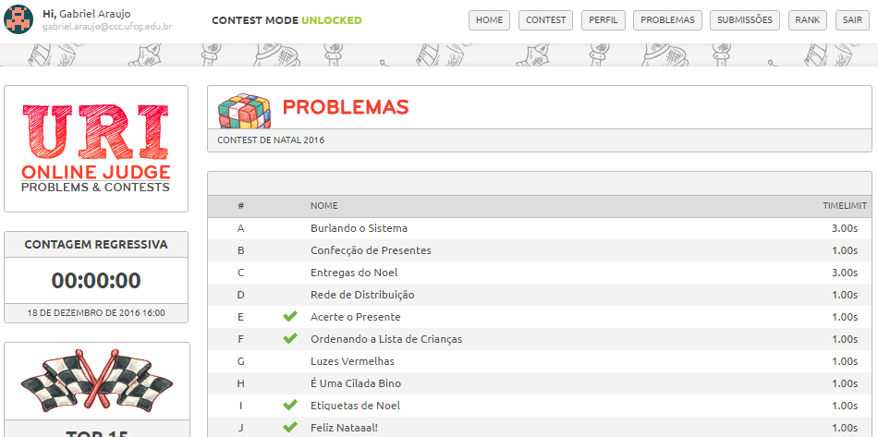

|  |  |
| --- | --- |
| Problema | Solução |
| E |  |
| F |  |
| I |  |
| J |  |